## **Creating Instances and Add Additional Volume (EBS) and Make Filesystem**

Step # 1 – Login Your **AWS Management Console** user/credentials and select **EC2**

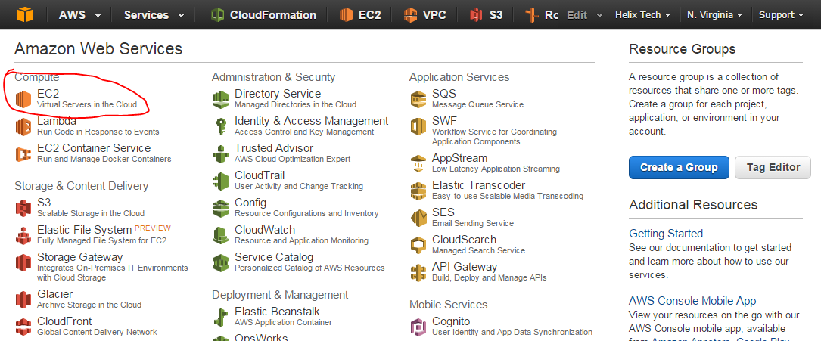

Step # 2 – On the **EC2 Dashboard**, select **Instances**, click **Launch**

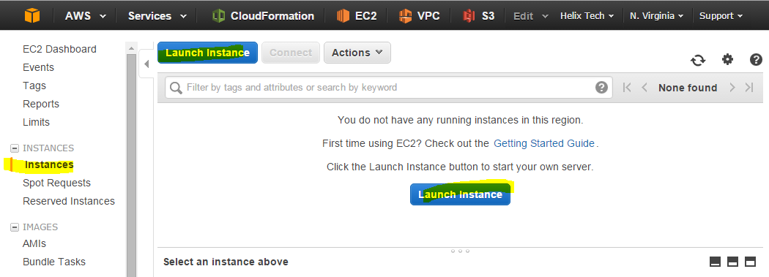

Step # 3 – On Choose AMI section, select desire **AMI** from **Quick Start | My AMIs | AWS Marketplace | Community AMIs** .

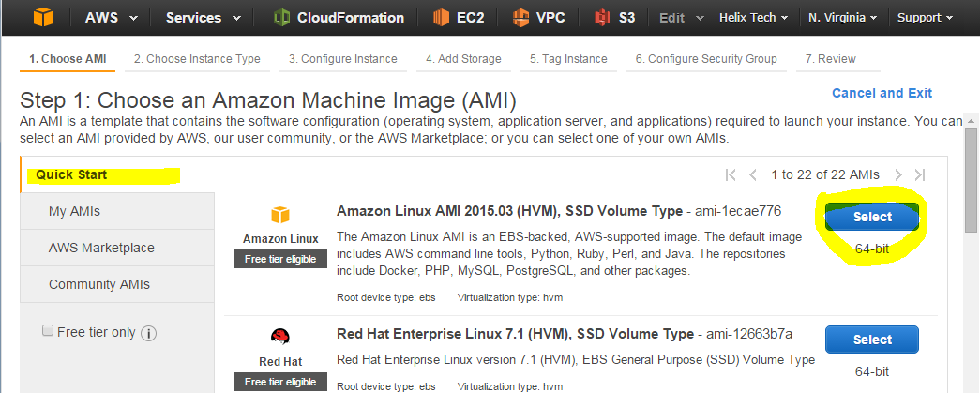

Step # 4 – Select the **Free Tier eligible** from **Choose Instance Type** and click **Next: Configure Instance Details**

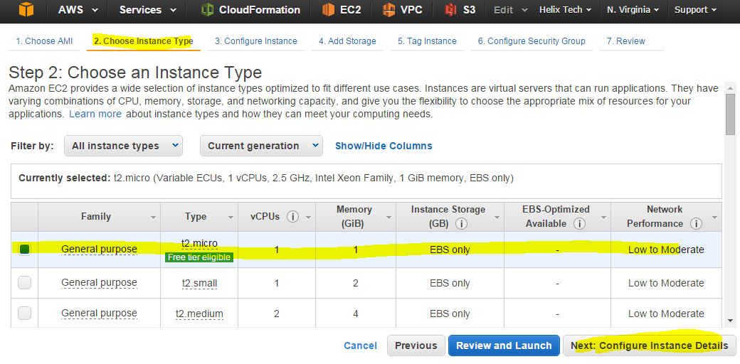

Step # 5 – Just Click **Next: Add Storage** from section **Configure Instance** without changing any things in this screen.

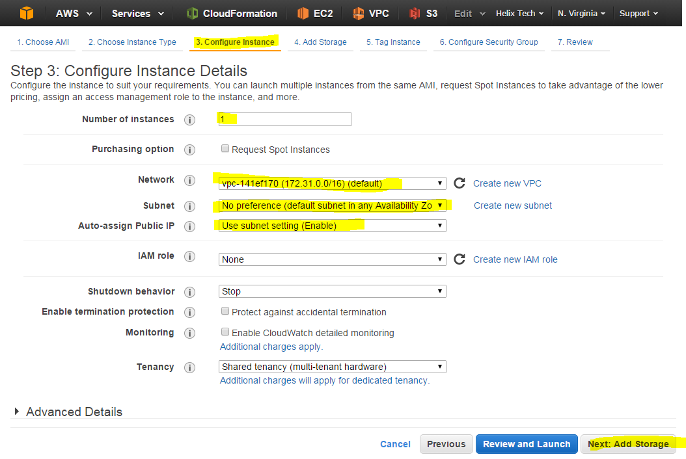

Step # 6 – Below screen section **Add Storage**, put the number of GB you want on your instances and click **Next:Tag Instance.** (Note you can add additional volume if you want but we are not doing right now, we want to do after instance is spun up and running).

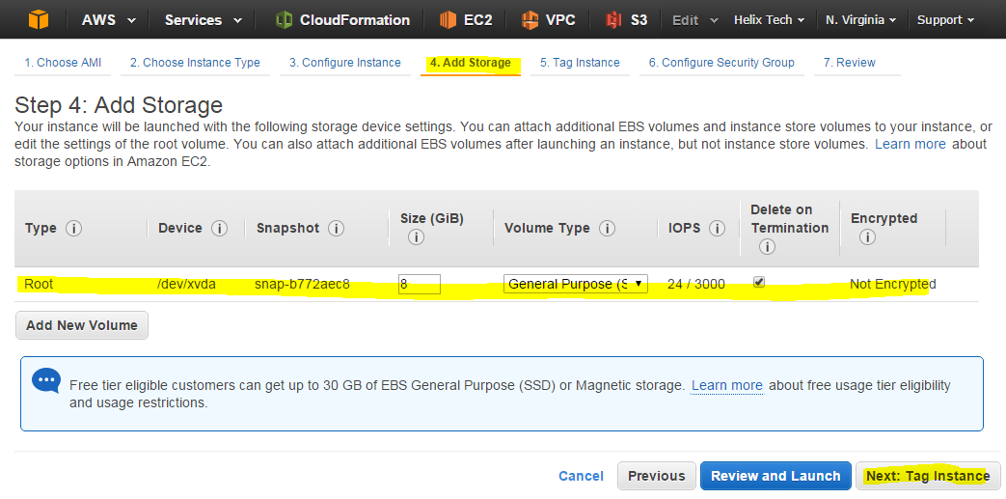

Step # 7 – On the **Tag Instance** section, provide Tag name = **EBS-Volume-2** (Tag name can be anything) and Click **Next: Configure Security Group**

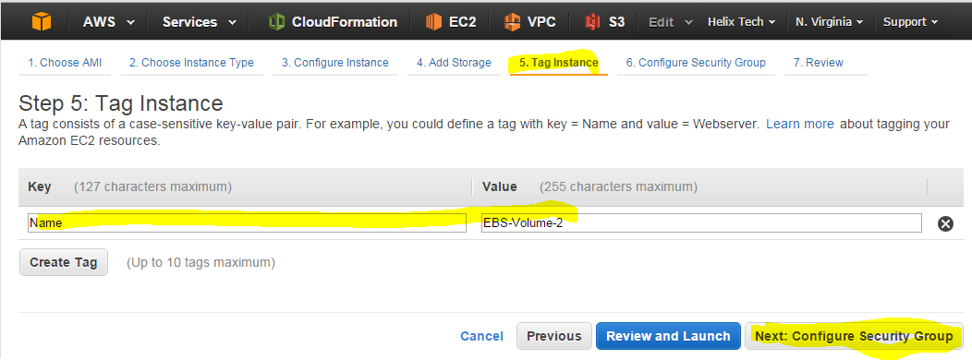

Step # 8 – On the **Configure Security Group** section, assign a Security Group section select **Create a New Security** , provide the SG group “as given below” and click **“Review and Launch”** (Note. You can named the security group as you want, it can be named with any name or if you have already Security Group which you want to use, simply choose the select an **existing** security group).

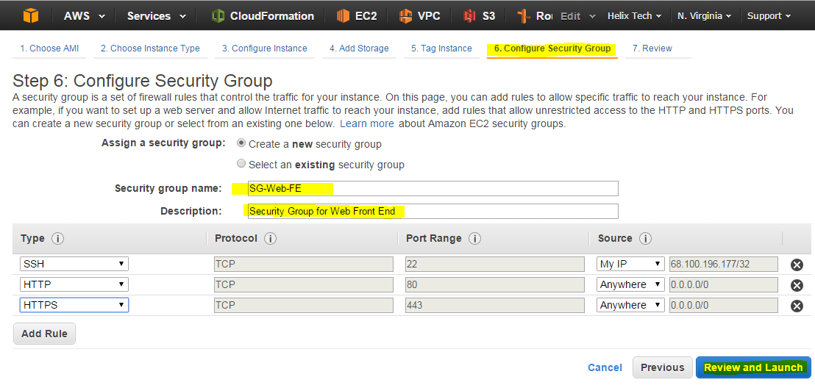

Step # 9 – **Review section** , verify all the selection you made are ok and click on **Launch** button as shown in the screen below.

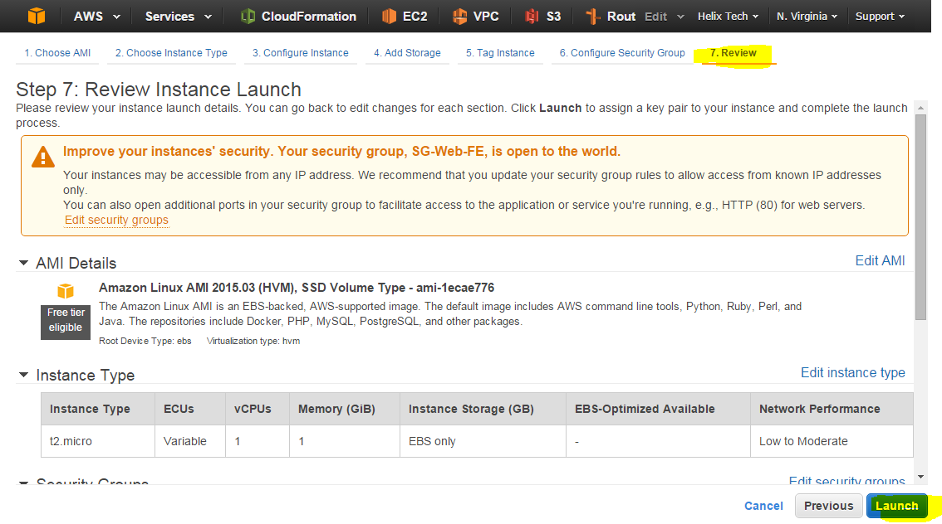

Step # 10 – From the list select **Create a new key pair**  and named as you want and click on **Download** (Note If you already have a **keypair** you don’t have create one, you can simply select the existing **keypair** from list and use the same.

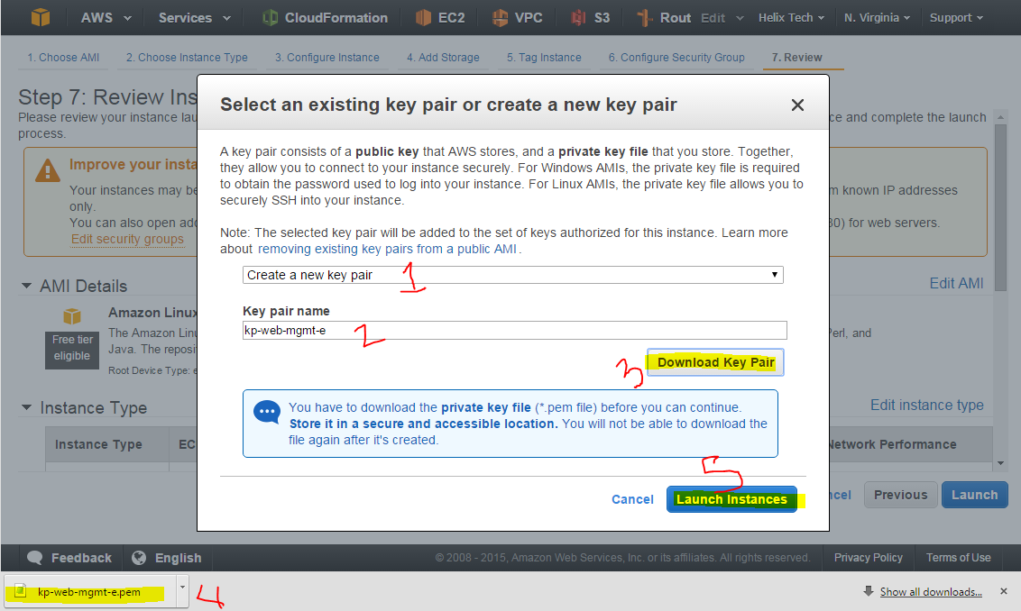

Step # 11 – Congratulation you’ve completed to create EC2 instance on AW Cloud.

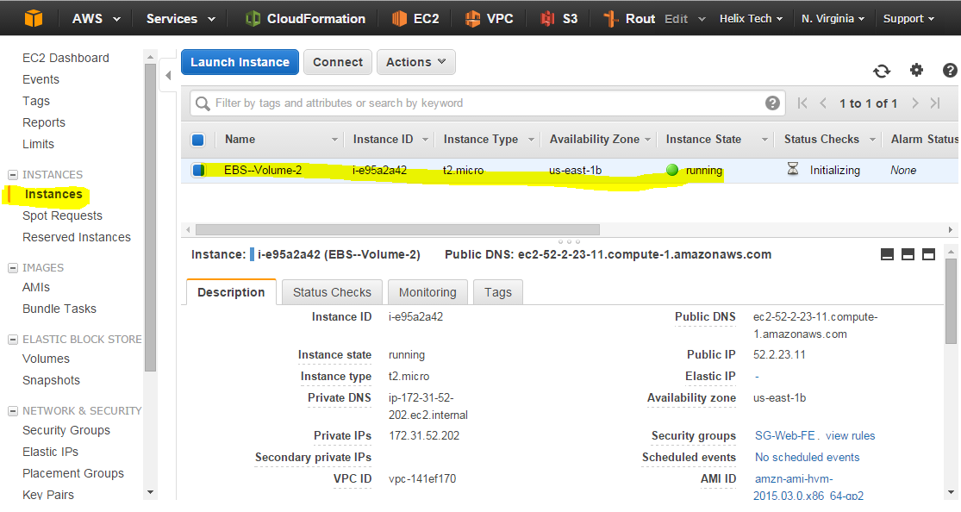

<http://docs.aws.amazon.com/AWSEC2/latest/UserGuide/ec2-launch-instance_linux.html>